Software Engineering & Project
Initial report - BLOCK UG-16
Maptek, Block Model Compression Algorithm

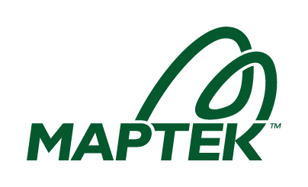

Name | Student ID
Adam Dao | a1797499
Calvin McCann | a1860428
Hamidur Rahim Mahir | a1914792
Izak Stentiford | a1822100
Mohammad Ali Rezaei | a1714717
Pezhman Beheshtian | a1661736
Tyler McKinley | a1716769
Yuzhe Ma | a1918429

Project Vision
Our project aims to develop a high-performance algorithm for compressing large-scale 3D block models without any loss of data. Block models are widely used in fields such as mining and geoscience, where datasets can become extremely large and computationally expensive to process (Sewnun, 2019). To address this challenge, our system will read uncompressed block model data, efficiently group neighbouring blocks with identical labels, and produce a compact, fully representative compressed output.
The vision is to design a solution that achieves both high compression ratios and fast execution speeds, striking the right balance between efficiency and accuracy. A key challenge lies in handling massive datasets under strict memory and functional constraints, guaranteeing the compressed output fully preserves the original model with no loss or duplication of data.
Ultimately, the project not only fulfils academic requirements but also simulates competitive, industry-relevant conditions through leaderboards. Our vision is to deliver a robust, optimised compression system that ranks among the best performing in the cohort.
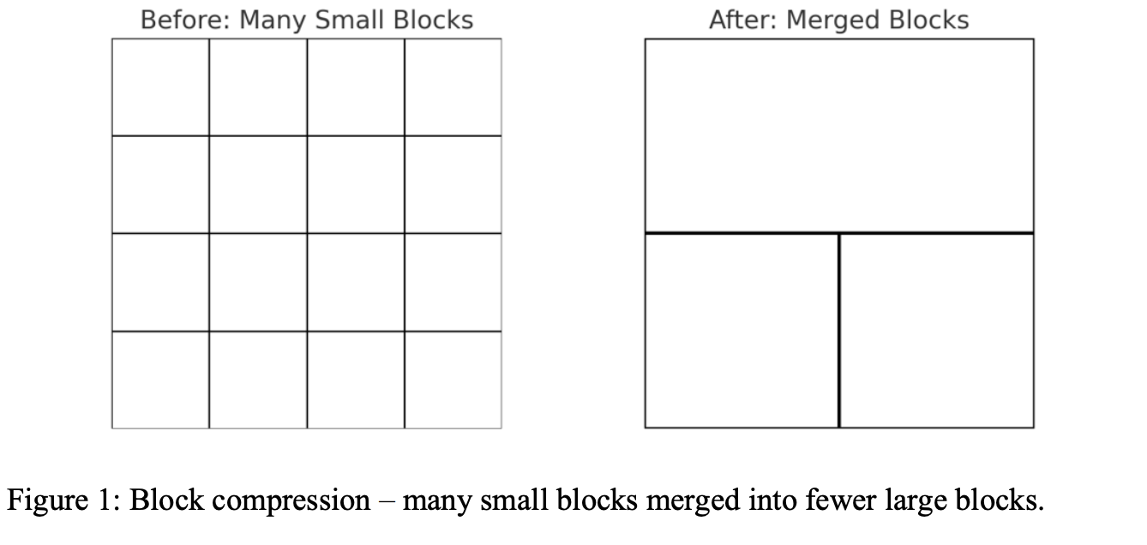

Customer Q&A
How should GitHub be used for this project?
Add the instructor to the repository. Push small, incremental changes and use GitHub projects to track progress. The instructor will provide feedback.
What is Titan and how will it be used?
Titan is the testing platform. Code is uploaded, test cases run automatically, and results show compression rate and speed. Requirements may change weekly (e.g., memory limits), so code should be continuously improved. Unlimited submissions are allowed.
How will feedback and assessment work?
Feedback will be provided by the TA, but fixing bugs is the team’s responsibility.
What are the performance expectations and data sizes we should design the compression algorithm for?
The TA clarified that Titan will test our solution on very large datasets, potentially hundreds of millions of blocks, under strict memory and runtime limits. While exact numbers may change each week, the algorithm should be designed to scale efficiently and avoid excessive memory use. This means we must prioritize both compression ratio and speed from the start.
What is the main communication channel?
Microsoft Teams will be used for all communication, including stand-up notes and task updates. Active participation is expected. TA is to be added to this channel for observation purposes.
What is the sprint length and Scrum Master role?
Sprints will last 2 weeks. The Scrum Master will also refactor tickets and plan two-week sprints.
Meeting Reflection
The kickoff meeting with Kareem was a success and set a solid foundation for the project. We clarified the usage of GitHub for version control, communication channels, and how sprints and retrospectives will be handled. Having the TA as both proxy client and teaching assistant, we needed to understand Kareem's involvement in the project. However, the meeting was somewhat unstructured at times, and we could have prepared clearer questions in advance to make better use of the time. For example, we initially focused heavily on tools (GitHub, Teams) rather than exploring the project’s technical risks and requirements. Going forward, the group has learned the value of balancing administrative setup with deeper discussions about scope, deliverables, and performance expectations.

For the next retrospective, we plan to bring concrete examples of challenges (e.g., sprint planning issues or testing problems) to get more targeted feedback. Overall, the kickoff successfully aligned the team, but greater preparation and prioritisation will make future meetings more efficient, allowing us to be more specific and proactive with our questions.

Users
The primary users of this design are mining engineers and geologists who are professionals working with large scale block models for resource estimation, mine planning, and geological analysis who need efficient data storage and transfer solutions. Also mining software developers who are part of the technical team developing or maintaining mining software applications that need to handle large block model datasets efficiently (Seequent, 2021).
The secondary users are data managers and consulting geologists. Data managers are IT professionals responsible for managing and archiving large geoscience datasets who need effective compression solutions to reduce storage costs and improve data transfer speeds. The consulting geologists are independent consultants who need to efficiently share large block model datasets with clients while maintaining complete data fidelity (Xplore Global Ltd, 2016).

Users Benefits
- Significant reduction in storage requirements for large block model archives
- Improved time efficiency when sharing datasets between teams, offices, and external partners.
- Reduced computational overhead when working with compressed datasets
- Precision in data accuracy for critical mining and geological decision making

Use Cases
The compression algorithm serves multiple practical applications across the mining and geoscience industries. Some use cases include archiving historical block models for long term storage, enabling efficient sharing of large datasets between remote mining operations and head offices, and reducing bandwidth requirements for cloud based geological analysis platforms. The system also optimises performance in real time mining simulation and planning applications while enabling efficient version control and backup of critical block model datasets, ensuring that organisations can maintain comprehensive data management practices without compromising on storage efficiency or data integrity.

Software Architecture
Pipeline:
- Input streaming (header, tags, slices).
- Parent-block scheduler in raster order.
- Compression steps: uniformity test, 2D tiling, 3D extrusion.
- Output writer: emit x,y,z,size,label.
- Parallelism: threads per parent-block.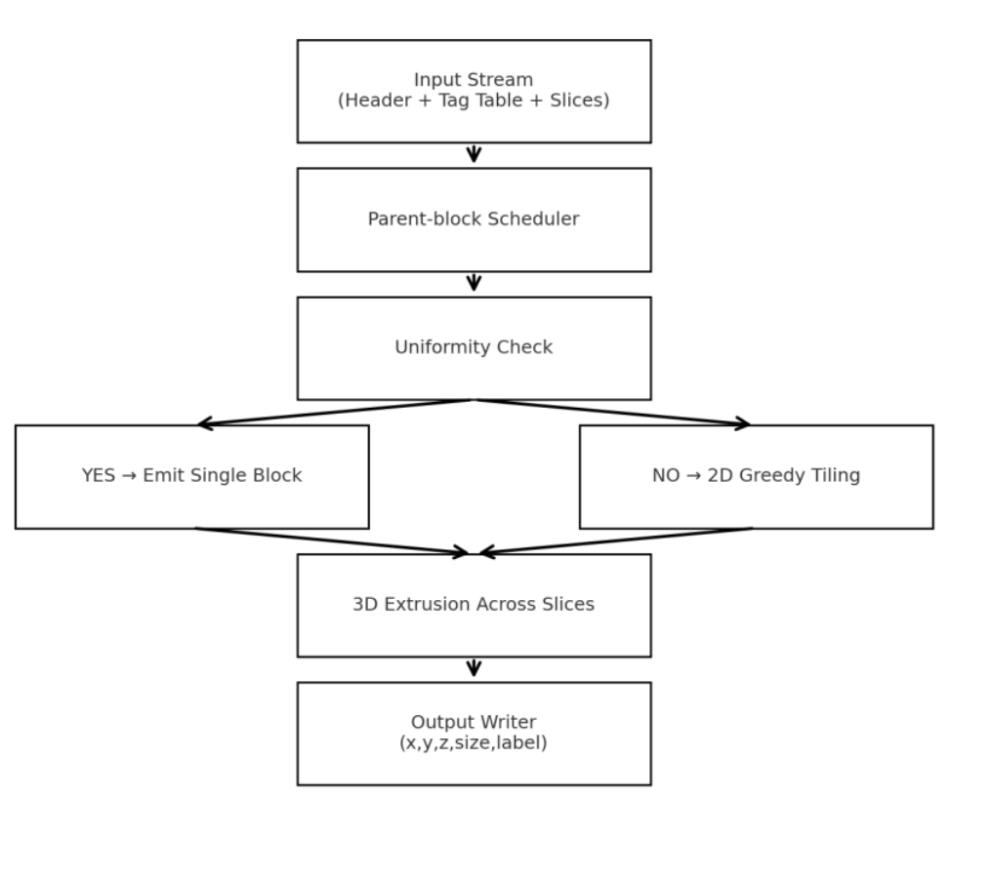

This system design uses a step-by-step pipeline to process and compress data efficiently. The input (with headers, tags, and slices) is read and organised in order. Each block is checked: if it is uniform, it is saved as a single block; if not, it is broken into smaller tiles. After this, the slices are combined in 3D, and the output is written with details like position, size, and label. The design also supports parallel processing, with multiple threads working on different blocks at the same time. This makes the system both fast and accurate.This pipeline minimizes memory usage by streaming input, while raster order ensures no data gaps. Uniformity tests and tiling merge homogeneous regions for higher compression, and parallel threads significantly improve runtime. These choices directly address the project’s dual goals of speed and high compression on massive datasets.

Tech Stack & Standards
This project is to be implemented in Python, following the competition and submission requirements of delivering a single .py file that reads from standard input and writes to standard output.
For development, the team will use GitHub for version control and collaboration. Communication is managed through Microsoft Teams for day-to-day discussions and Github Projects for task tracking, ensuring transparency and accountability throughout the project lifecycle.
Our coding standards focus on producing readable, maintainable, and robust code:
- Modularity: Code is organised into clear, single-purpose functions to separate input handling, compression logic, and output formatting.
- Readability: Consistent indentation, meaningful variable names, and line length limits ensure clarity.
- Comments & Documentation: Functions include concise, informative comments explaining logic, assumptions, and edge cases.
- Testing: Functions are tested individually during development to catch errors early and ensure correct output on a variety of inputs.
- Error Handling: Inputs are validated, and exceptions are handled gracefully to prevent crashes.
These standards are designed to promote team consistency, code quality, and maintainability, while fully complying with the project’s constraints. This will allow easier collaboration between the relatively large team of 8 members.

Group Meetings and Team Member Roles
Our team will meet virtually on a weekly basis, every Wednesday from 5:00 pm to 6:00/7:00 pm. This is in addition to the fortnightly TA meetings. These meetings will provide a dedicated time to discuss progress, review tasks, and address any challenges encountered during the sprint. Each session will follow a structured agenda to maximise productivity.
Before meetings, team members are expected to prepare by:
- Reviewing the progress of the current sprint against planned tasks.
- Identifying completed and pending items.
- Preparing questions or discussion points regarding roadblocks, process improvements, and lessons learned.
This preparation ensures that retrospectives are focused, actionable, and contribute to continuous improvement.
The team will communicate with the tutor primarily through Microsoft Teams, allowing us to seek clarification, provide updates, and receive timely feedback.
Scrum Master responsibilities will rotate among team members for each sprint to ensure shared leadership and engagement. The assignments are as follows:
- Sprint 1 (week 3, 4): Calvin McCann
- Sprint 2 (week 5, 6): Pezhman Beheshtian
- Sprint 3 (week 7, 8): Tyler McKinley
- Sprint 4 (week 9, 10): Izak Stentiford
- Sprint 5 (week 11, 12): Mohammad Ali Rezaei
Aside from the rotating Scrum Master fortnightly, all members contribute as developers. The Product Owner role is filled by our TA (acting as proxy client), and the team practices collective ownership of project deliverables.

Further Research
Compression Families at a Glance
- Run-Length Encoding (RLE): simple, streaming-friendly, weak on noisy data.
- Dictionary methods (LZ77/LZW/DEFLATE/Zstd/Brotli): byte-focused, not optimal for block count.
- Entropy coding (Huffman/Arithmetic): saves bits but not blocks.
- Tree/Graph (Octree/Quadtree): effective on uniform regions, hierarchical output.
- Segmentation/Connected Components: handles irregular shapes, slower.
Compression Algorithms
- Per-slice RLE + maximal rectangles: efficiently tile slices using runs and histograms.
- 3D extrusion: extend rectangles across slices if footprints and labels match.
- Uniform parent detection: collapse parent block if all cells share the same label.
- Optional: octree shortcuts or connected-component tiling for irregular cases
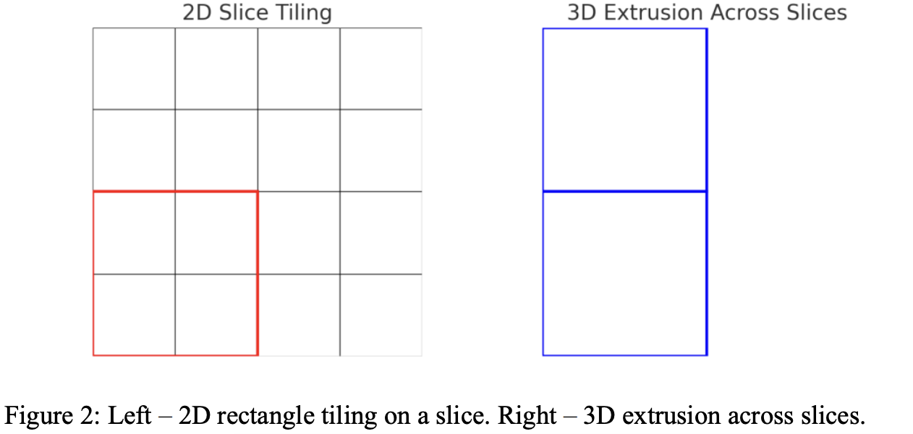

Software Engineering & Project
Snapshot week 3 - BLOCK UG-16
Maptek, Block Model Compression Algorithm

Product Backlog and Task Board

Product Backlog
Task | Description
Compression Algorithms Research | Research compression algorithms and create a document sharing the findings with the rest of the team
Titan Acceptance Test | Create a python file that implements the stream processor converting the input format to the output format and submit to Titan
Titan Initial Submission | Create a python file that implements the stream processor as well as a compression algorithm and submit to Titan
Snapshot 1.1 | Create snapshot 1.1
Initial Report | Create initial report
Improved Submission | Create a python file that improves on the initial submission through a faster algorithm or a more efficient algorithm
Sprint Backlog and User Stories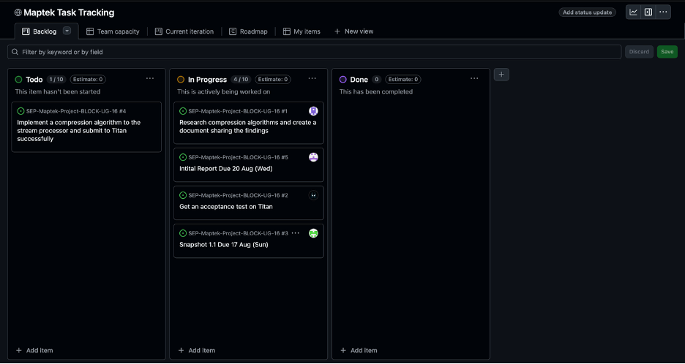

Sprint Backlog
Task | Description
Compression Algorithms Research | Research compression algorithms and create a document sharing the findings with the rest of the team
Titan Acceptance Test | Create a python file that implements the stream processor converting the input format to the output format and submit to Titan
Titan Initial Submission | Create a python file that implements the stream processor as well as a compression algorithm and submit to Titan
Snapshot 1.1 | Create snapshot 1.1
Initial Report | Create initial report
User Stories (Sprint 1)
As developers, we want to research existing compression algorithms so that our team can choose an efficient method for compressing block models.
As the Product Owner (TA), I want a minimal Python script that can run on Titan without errors so that I can confirm the input/output pipeline works correctly before adding complex compression.
Definition of Done
Complete the Titan Initial Submission task which involves a working submission on Titan that implements the stream processor and compression algorithm.
Summary of Changes
This week marked the kick-off of the project. The group set up communication channels, version control, and task tracking tools. The product backlog and sprint backlog were finalized, and research into compression algorithms was conducted to support future development. The team also began drafting the initial report and group charter, outlining roles and responsibilities. However, a significant obstacle was encountered: despite having received the Titan access password, the group was unable to log in to Titan, which has blocked progress on initial testing. The team is actively seeking a resolution to this access issue while continuing research and documentation work

References
Seequent. (2021). Geoscience data management report 2021. Seequent. https://files.seequent.com/PDFs/Seequent-Geoscience-Data-Management-Report-2021.pdf?utm_source=chatgpt.com
Senwun, D. (2019). The creation and application of a geotechnical block model for an underground mining project. Ground Support 2019, 1(1), 479-492. https://papers.acg.uwa.edu.au/p/1925_34_Sewnun/
Xplore Global Ltd. (2016). Geoscience data management challenges. Xplore.global. https://xplore.global/storage/2025/01/exploration-data-management-facts.pdf?utm_source=chatgpt.com

